**Computer Networks**

**LAB # 7**

**Basic Networking Commands and connect the computers in Local Area Network.**

**Commands :**

1. **enable**: This command enters privileged EXEC mode, allowing access to all available commands on the device.
2. **configure terminal**: Enters global configuration mode, where you can make changes to the device's configuration.
3. **interface [interface type] [interface number]**: This command allows you to enter interface configuration mode for a specific interface, such as Ethernet, FastEthernet, GigabitEthernet, etc.
4. **ip address [IP address] [subnet mask]**: Assigns an IP address and subnet mask to an interface.
5. **no shutdown**: Enables the interface, allowing traffic to pass through it.
6. **show ip interface brief**: Displays a brief summary of all interfaces on the device along with their IP addresses and status.
7. **hostname [name]**: Changes the hostname of the device.
8. **clock rate [value]**: Configures the clock rate on a serial interface, typically used when connecting to a WAN link.
9. **description [description]**: Adds a description to an interface for documentation purposes.
10. **copy running-config startup-config**: Saves the current running configuration to the startup configuration, ensuring changes persist across reboots.
11. **ping [IP address]**: Tests connectivity to another device by sending ICMP echo requests.
12. **traceroute [IP address]**: Determines the path packets take from the source to the destination, showing each hop along the way.
13. **telnet [IP address]**: Initiates a Telnet session to the specified IP address, allowing remote access to another device.
14. **ssh [IP address]**: Initiates a Secure Shell (SSH) session to the specified IP address, providing secure remote access to another device.
15. **show version**: Displays information about the device's hardware and software, including the IOS version.
16. **show running-config**: Displays the current running configuration of the device.
17. **show startup-config**: Displays the contents of the startup configuration, which is the configuration that will be loaded upon reboot.
18. **clear arp-cache**: Clears the Address Resolution Protocol (ARP) cache, which maps IP addresses to MAC addresses on the local network.
19. **write memory**: Saves the current running configuration to the startup configuration, similar to "copy running-config startup-config".
20. **shutdown**: Disables an interface, preventing traffic from passing through it.

**Connectivity of computers In LAN**

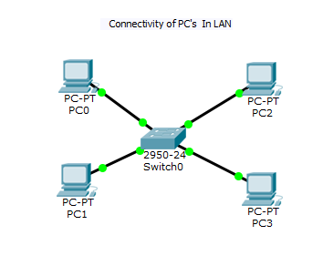

* **Make the successful communication between these PC’s (Local Area Network) as you make in your previous tasks.**